DOS & DONTS
PRE-PLE 2025
HOT SET 3
ENGLISH
Time Allowed: 2 hours 15 minutes
Random No. |  |  |  |  |  | Personal No.

Candidate’s Name……………………………………………………………………….
Signature……………………………………………………..………………………........
School Name: …………………………………………………..…………………………
FOR EXAMINERS’ USE ONLY
QN NO. | MARKS | EXR’S  NO.
1 - 10
11 - 20
21- 30
31 - 40
41 - 43
44 - 46
47 - 50
51
52
53
54
55
TOTAL
Read the following instructions carefully:
1. Answer all the questions. All the working for
both sections A and B must be shown in the
spaces provided.
2. All the working must be done using a blue or
black ball point pen or ink. Any work done in
Pencil other than graphs and diagrams will
Not be marked.
3. No calculators are allowed in the examination
Room.
4. Unnecessary changes in your work
and handwriting that cannot be read easily may lead to loss of marks.

5. Do not fill anything in the table indicated
“FOR EXAMINERS’ USE ONLY” and in the
boxes inside the question paper.

SECTION A: 50 MARKS
In questions 1 to 5, fill in the blank space with a suitable word.
1. ………………………… article I wrote yesterday had simple English.
2. Paul is my ………………………. because he is my mother’s son.
3. The pupils celebrated when we broke ……………………. for second term holidays.
4. One is always expected to respect ……………………. in everything one does.
5. Bongole is the boy ………………….. results were withheld for copying in the exam.
For questions 6 – 15, complete each sentence with the correct form of the word in brackets.
6. Having ………………………. the dress, the tailor put it on display for sale. (sew)
7. We should always be …………………………. to one another all the time. (help)
8. The chairperson told me to speak ……………………….. during the debate. (loud)
9. There is no …………………………. between the head girl and our teacher. (relate)
10. Motorists must brake ………………………. they see animals on the road.(immediate)
11. Most traders closed ………………………. shops during the riots in the city. (they)
12. The police help in promoting …………………………. in our community. (secure)
13. An uncle of ………………………. was the chief guest during our Sports Day. (she)
14. Mr Swaga has ………………………….. to Nairobi for treatment. (to fly)
15. Our music teacher is …………………… than all the teachers at school. (friend)
For questions 16 – 17, arrange the following words in alphabetical order.
16. withdraw save deposit money
…………………………………………………………………………………………………………..
17. advert advise admission advice
…………………………………………………………………………………………………………..

For questions 18 – 20, rewrite the sentence giving one word for the underlined group of words.
18. The tailor forgot his protective cap worn on the finger while sewing at home.
…………………………………………………………………………………………………………..
19. During the time when candidates were asking for votes, Sandra promised to better the food served at school.
…………………………………………………………………………………………………………..
20. It is not good to fail to refuse gifts strangers.
…………………………………………………………………………………………………………..
In questions 21 – 22, write the following abbreviations in full
21. they’re ………………………………………………………………………………………………
22. Maj. …………………………………………………………………………………………………….
In questions 23 – 24, use each of the given words in a sentence to show that you know the difference in their meaning.
23. uncle: ………………………………………………………………………………………………….
24. ankle: ………………………………………………………………………………………………….
In questions 25 – 26, rearrange the given words to make correct sentences.
25. TV is Mr Tego What presenter a funny!
…………………………………………………………………………………………………………
26. man is Mwesige rich to a married.
…………………………………………………………………………………………………………
For questions 27 – 28, write the singular form of the following words.
27. mouths ………………………………………………………………………………………………...
28. berries …………………………………………………………………………………………………
In questions 29 – 30, rewrite the sentences giving the opposite of the underlined words.
29. Zahara spent all the money she won in the spelling contest.
…………………………………………………………………………………………………………
30. Most pupils wear closed shoes on weekends.
…………………………………………………………………………………………………………

Rewrite the given sentences as instructed in brackets.
31. Turya has written a letter alone. (Rewrite using:…………..himself………)
…………………………………………………………………………………………………………
32. The pupils said that they had not understood what their teacher had taught the previous day. (Rewrite using: ”………………………..” the pupils said.)
…………………………………………………………………………………………………………
33. This vehicle is in a bad mechanical condition, so it can’t transport us on tour.
(Rewrite using:………………………..if……………………….)
…………………………………………………………………………………………………………
34. You will go to the library at 4:00 pm. The match will end at 3:00 pm.
(Rewrite as one sentence using:…….….by the time………….)
…………………………………………………………………………………………………………
35. The visitors had hardly arrived when I gave them water to drink.
(Rewrite and begin: As soon as……………)
…………………………………………………………………………………………………………
36. Takali hasn’t taken medicine for four months now.
(Rewrite using:…………..since……………..)
…………………………………………………………………………………………………………
37. The plumber may repair our water pipes today. (Rewrite and use:……..likely……)
…………………………………………………………………………………………………………
38. None of them has failed to complete the race. (Rewrite and begin: All………)
…………………………………………………………………………………………………………

39. There are almost no mangoes in this basket.
(Rewrite the sentence using:………….hardly…………..)
…………………………………………………………………………………………………………
40. People in dry areas plant trees. They want to get enough rain.
(Rewrite using: In order………………………..)
…………………………………………………………………………………………………………
41. The passengers got out when the bus reached the checkpoint.
(Rewrite the sentence using:…………….arrived…………………)
…………………………………………………………………………………………………………
42. Animals need care much as they are not human beings.
(Rewrite the sentence beginning: Despite…………)
…………………………………………………………………………………………………………
43. They will reconnect your DSTV as soon as you pay the subscription.
(Rewrite the sentence beginning: Your………..)
…………………………………………………………………………………………………………
44. There was no need for the mother to punish her baby.
(Rewrite the sentence using:………………needn’t……………)
…………………………………………………………………………………………………………
45. The shopkeeper has sold a lot of things today, hasn’t she?
(Rewrite the sentence and end:…………….……has she?)
…………………………………………………………………………………………………………
46. All parents will be invited for a meeting. Their children failed the mock exams. (Join the two sentences using:…….whose……..)
…………………………………………………………………………………………………………

47. Mr Mulindwa is a teacher. Mr Mulindwa is also a farmer.
(Join the two sentences using: ………………both……………..)
…………………………………………………………………………………………………………
48. The food was delicious. We ate all the food.
(Rewrite as one sentence using:………….such………….that………..)
…………………………………………………………………………………………………………
49. In case Ali works hard, he will get good results.
(Rewrite using: The ……………, the…….)
…………………………………………………………………………………………………………
50. Nabadda prefers listening to music to watching comedy.
(Rewrite the sentence using:………………… would rather……………..)
…………………………………………………………………………………………………………
SECTION B:50 MARKS
51. Read the passage below carefully and, in full sentences, answer the questions about it.
Animal needs and freedoms are essential requirements that must be put in place to ensure that bodies of animals function healthily.
Animals, like people, need freedom and comfort in their habitats to help them get enough physical and social stimulation. This helps them to satisfy their behavioural needs like eating enough food, drinking clean water, resting without being disturbed, mating to increase their number and taking care of their young ones.
Animals need protection from harm by poachers and encroachers. These encroachers not only cause fear but also stress animals which make them run from place to place. This running makes it difficult for animals to display their natural behaviour like hunting, climbing trees and making territories or boundaries.
Animals whether, in homes or in bushes, need to be free from pain, injury and diseases because they are also affected by illness. So they should also be treated by vets through regular monitoring for their health and well-being.

Besides the above, animals need to be free from endless noise in their environment, as this scares them and makes them behave wildly. This explains why vehicles in game parks aren’t allowed to hoot, for it scares animals.
It is therefore, important for animals to have rights, needs and freedoms which people also need most.

Questions:
(a) What is the passage about?
…………………………………………………………………………………………………………
(b) According to the passage, what are animal needs and freedoms?
…………………………………………………………………………………………………………
(c) Why are animal needs and freedoms essential to animals?
…………………………………………………………………………………………………………
(d) Write any one way animals satisfy their behavioural needs according to the passage.
…………………………………………………………………………………………………………
(e) How harmful are poachers and encroachers to animals?
…………………………………………………………………………………………………………
(f) When do animals behave wildly?
…………………………………………………………………………………………………………
(g) What shows that there is a need to keep animals free from noise?
…………………………………………………………………………………………………………
(h) Give another word or group of words similar in meaning to the following as used in the passage.
(i) habitat ………………………………………………………………………………………...
(ii) display …………………………………………………………………………………………
(j) Suggest a suitable title to the passage.
…………………………………………………………………………………………………………

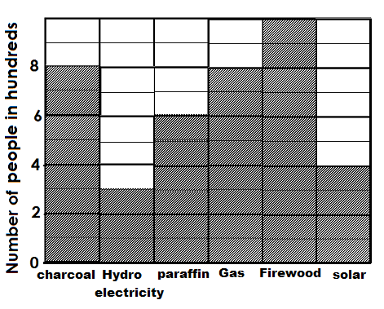52. The graph below shows the rate of fuel consumption in Mambo Sub-county. Study it carefully and, in full sentences, answer the questions about it.

Questions:
a) What does the graph above show?
…………………………………………………………………………………………………………
b) How many people use hydro electricity according to the graph?
…………………………………………………………………………………………………………
c) Why do you think many people use firewood?
…………………………………………………………………………………………………………
d) Which fuel is least used by the people in Mambo sub-county?
…………………………………………………………………………………………………………
e) Which fuels have the same rate of consumption?
…………………………………………………………………………………………………………
f) What is the difference between the highest and the lowest fuel consumption?
…………………………………………………………………………………………………………
g) How does the use of charcoal affect the environment?
…………………………………………………………………………………………………………
h) Why do you think few people in Mambo sub-county use electricity?
…………………………………………………………………………………………………………
- How many sources of fuel are on the graph?
…………………………………………………………………………………………………………
j) How can the government reduce the number of people using firewood in Mambo sub-county?
…………………………………………………………………………………………………………

53. Read the poem carefully and answer the questions about it in full sentences.
In my cozy room, I rest my head
Oh a soft pillow, in a warm bed.
I imagine a storm outside,
Clouds rush and collide with pride.

Lightning flashes, thunder roars loud,
A tree falls down with a mighty boom
No mangoes next season; What a shame!
The storm is strong, nothing I can do.

It’s raining cats and dogs, you see,
Pitter-patter on the roof, a sweet melody.
Our maize crop drinks the rain with a smile,
But shivering with cold, Nandi the bull does.

This sunny morning, I forecast rain,
I need to get ready, for the season.
A rain coat, gumboots, and an umbrella too,
If not, I ‘ll miss school on a rainy day.
Questions:
(a) Where is the speaker resting his head?
…………………………………………………………………………………………………………
(b) What is happening to the clouds?
…………………………………………………………………………………………………………
(c) In which stanza does the tree fall down?
…………………………………………………………………………………………………………
(d) How many verses are in the poem?
…………………………………………………………………………………………………………
(e) Which tree is affected by the weather according to the second stanza?
…………………………………………………………………………………………………………
(f) What happens to Nandi when it is cold?
…………………………………………………………………………………………………………
(g) What does the speaker mean by “raining cats and dogs”?
…………………………………………………………………………………………………………

(h) Where do you think the speaker goes whenever there’s no rain in the morning?
…………………………………………………………………………………………………………
(i) Give a word or a group of words that can mean the same as the underlined word ready as used in the poem.
…………………………………………………………………………………………………………
(j) Suggest a suitable title for this poem.
…………………………………………………………………………………………………………
54. Pictures A – F tell a story. Study them carefully and then describe what is happening in each picture. You may use the words below to guide you.
sewing tailor go cloths sewing measurements boy paying try on sewing machine uniform tape measure

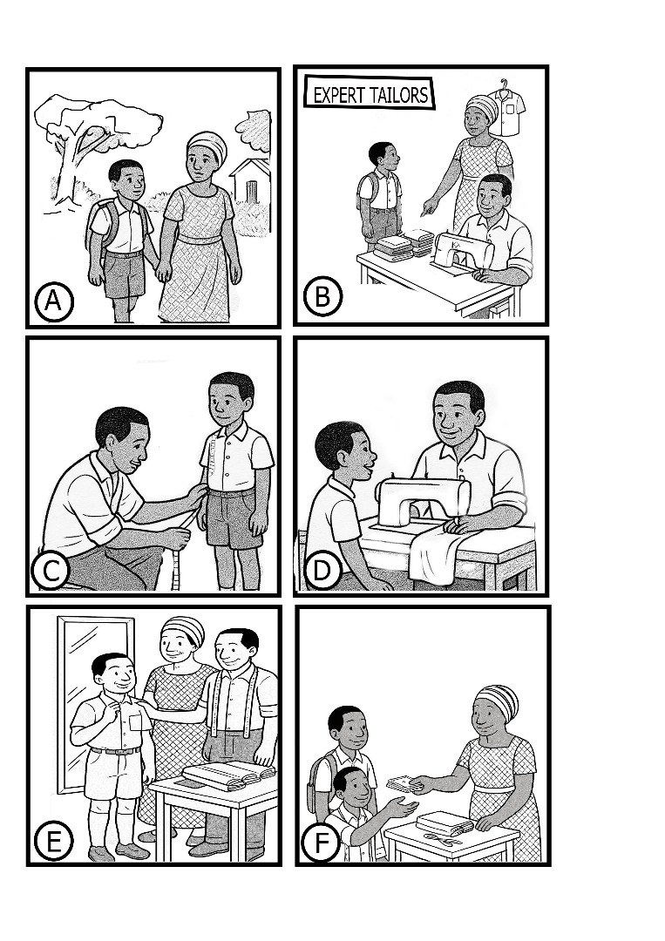

(a) Picture A:
…………………………………………………………………………………………………………
(b) Picture B:
…………………………………………………………………………………………………………
(c) Picture C:
…………………………………………………………………………………………………………
(d) Picture D:
…………………………………………………………………………………………………………
(e) Picture E:
…………………………………………………………………………………………………………
(f) Picture F:
…………………………………………………………………………………………………………
(g) What do you think the boy’s mother is telling the tailor in picture B?
…………………………………………………………………………………………………………
(h) Why is the tailor doing the action in picture C?
…………………………………………………………………………………………………………
(i) Write any one tool you think the tailor in this picture story uses.
…………………………………………………………………………………………………………
(j) How many characters are in the above picture story?
…………………………………………………………………………………………………………

55. You are Kutuma Levy, last year, you sat Primary Leaving Examination at Denja Primary School, P O Box 339, Maaro. You received your P.L.E. results as follows; MTC 2, SST 1, SCIENCE 2 and ENGLISH 1. Your father; Mr Tusimbudde Gabrel who runs a carpentry workshop in Nsanafu Village went with you to look for a vacancy in Juwa Kaali Secondary School this year. In capital letters, use this information to fill in and complete part of the admission form below.

JUWA KAALI SECONDARY SCHOOL
P.O.BOX 29329, MAARO Tel: 0774586158/ 0702715100.
info@juwakaalisecondaryschool.ug/juwakaalischool2019@gmail.com
Web: www.juwakaalisecondaryschool.ug

ADMISSION FORM EXTRACT
Student’s Full Name | :
Age | :
Former School | :
PLE year | :
Aggregate obtained | :
Division | :
Admitted in (Form / Class) | :
Parent’s Full Name | :
Contact / e-mail | : 0774 686148 / gabytusimbudde@gmail.com
Place of Work | :
Occupation | :

“Enabling Victory”

END

